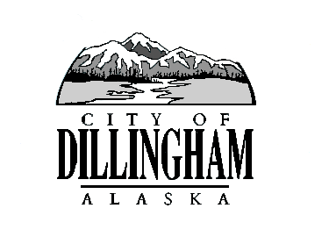
CITY OF

ALASKA
DILLINGHAM

HMAM
NOTICE OF A PUBLIC HEARING
Public Hearing on Ordinance No. 2025-03

The City Of Dillingham will hold a Public Hearing on Thursday, November 6, 2025, at 7:00 P.M. in the City Council Chambers for the purpose of taking comment from the public on the following ordinance:
- Ordinance No. 2025-03, An Ordinance of the Dillingham City Council Amending the Budget by Adopting Budget Amendment No. 1 and Appropriating Funds for the FY 2026 City of Dillingham Budget.
If you have any questions, please contact the City Clerk’s office at (907) 842-5212 or email cityclerk@dillinghamak.us.

