Alice Ruby, Mayor

Council Members
• Tracy Hightower (Seat A) • Chris Maines (Seat B) • Misty Savo (Seat C)
• Curt Armstrong (Seat D) • Andy Anderson (Seat E) • Paul Liedberg (Seat F)
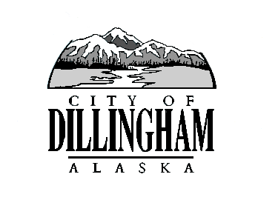
CITY OF

ALASKA
DILLINGHAM

HMAM

DILLINGHAM CITY COUNCIL

David B. Carlson Council Chambers
Dillingham City Hall, 141 Main Street, Dillingham, AK 99576 (907) 842-5212
SPECIAL MEETING | 5:30 P.M. | OCTOBER 12, 2017

1. CALL TO ORDER

2. ROLL CALL

3. APPROVAL OF AGENDA

4. CITIZEN’S DISCUSSION (Prior Notice or Agenda Items)

5. SPECIAL BUSINESS

a. Certify the Election of October 3, 2017, Adopt Resolution No. 2017-43, A Resolution of the Dillingham City Council Accepting the Certification of the Canvassing Committee Results and Certifying the October 3, 2017 Regular City Election page 3

b. Adopt Resolution 2017-44, Award Task Order #2 to CRW Engineering Group for Design Services for Water System Improvements Project: Connecting Loops and System Infrastructure Replacement

c. Swearing in Ceremony of Newly Elected Council Members

6. CITIZEN’S DISCUSSION (Open to the Public)

7. COUNCIL COMMENTS

8. MAYOR’S COMMENTS

9. ADJOURNMENT

