|  |
| --- |
| Alice Ruby, **Mayor** |
| **Council Members** |
| • Chris Napoli (Seat A) • Chris Maines (Seat B) • Aksel Buholm (Seat C) |
| • Curt Armstrong (Seat D) • Andy Anderson (Seat E) • Gregg Marxmiller (Seat F) |

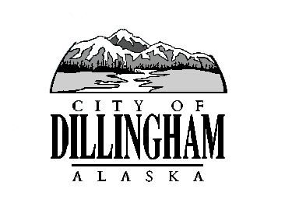

CITY OF

ALASKA

DILLINGHAM

**HMAM**

# DILLINGHAM CITY COUNCIL

David B. Carlson Council Chambers

Dillingham City Hall, 141 Main Street, Dillingham, AK 99576 (907) 842-5212

|  |  |  |
| --- | --- | --- |
| **SPECIAL COUNCIL MEETING** | **7:00 P.M.** | **JANUARY 24, 2019** |

**1. CALL TO ORDER**

**2. ROLL CALL**

**3. APPROVAL OF AGENDA**

**4. PUBLIC HEARINGS**

1. Ordinance 2019-01, An Ordinance of the Dillingham City Council Authorizing the City to Issue General Obligation Bonds in the Principal Amount Not to Exceed $4,053,941 to Finance the Construction of Roads, and for the Construction of an Addition to the Lake Road Fire Hall; and Submit the Question of the Issuance of Such Bonds to the Qualified Voters of the City of Dillingham, at the Election to be Held in the Municipality on March 26, 2019 *(Introduced January 10, 2019)*

**5. SPECIAL BUSINESS**

1. Adopt Ordinance 2019-01, An Ordinance of the Dillingham City Council Authorizing the City to Issue General Obligation Bonds in the Principal Amount Not to Exceed $4,053,941 to Finance the Construction of Roads, and for the Construction of an Addition to the Lake Road Fire Hall; and Submit the Question of the Issuance of Such Bonds to the Qualified Voters of the City of Dillingham, at the Election to be Held in the Municipality on March 26, 2019 *(Introduced January 10, 2019)*
2. Approve Resolution 2019-04, A Resolution of the Dillingham City Council Appointing an Alternate Community Representative to the BBEDC Board of Directors
3. Bond Community Engagement Plan *(to be distributed at the meeting)*

**6. CITIZEN’S DISCUSSION (Open to the Public)**

**7. COUNCIL COMMENTS**

**8. MAYOR’S COMMENTS**

**9. ADJOURNMENT**