Council Members
• Chris Napoli (Seat A) • Chris Maines (Seat B) • Aksel Buholm (Seat C)
• Curt Armstrong (Seat D) • Andy Anderson (Seat E) • Gregg Marxmiller (Seat F)
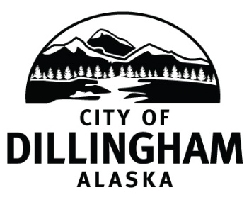

DILLINGHAM CITY COUNCIL

David B. Carlson Council Chambers
Dillingham City Hall, 141 Main Street, Dillingham, AK 99576 (907) 842-5212
SPECIAL COUNCIL MEETING | 10:00 A.M. | APRIL 15, 2019

1. CALL TO ORDER

2. ROLL CALL

3. APPROVAL OF AGENDA

4. SPECIAL BUSINESS
- Adopt Resolution No. 2019-13; A Resolution of the Dillingham City Council Authorizing the City of Dillingham to Issue General Obligation Bonds in the Principal Amount of Not to Exceed $4,053,941 to Finance the Construction of Roads, and for the Construction of an Addition to the Lake Road Fire Hall; Fixing Certain Details of Such Bonds, and Authorizing Their Sale

6. CITIZEN’S DISCUSSION (Open to the Public)

7. COUNCIL COMMENTS

8. MAYOR’S COMMENTS

9. ADJOURNMENT

