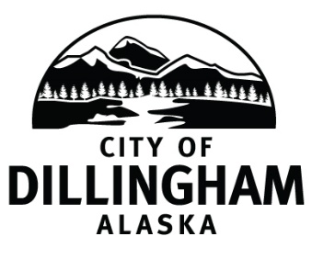

**CITY ELECTION OCTOBER 7, 2025**

**NOTICE OF ELECTED OFFICES TO BE FILLED**

**UPDATED ON 08/27/2025\***

**If you are interested in being a candidate for the upcoming City Election, October 7, 2025, visit the City Clerk’s office at City Hall. You can file for candidacy during regular work hours, Monday – Friday, 8 a.m. – 5 p.m.**

Candidate filing begins August 12, 2025, and ends September 2, 2025

Seats open for candidacy are:

Council Seat A, three year term School Board Seat A, three year term

Council Seat B, three year term \***School Board Seat E, two year term**

**\*School Board Seat B, one year term**

Candidate Qualifications

* Be a registered qualified voter of the City of Dillingham;
* Be a resident of the City for one year immediately prior to the election;
* Must file a *Declaration of Candidacy Form* with the City Clerk’s Office.

A person may vote in city elections only if they are registered to vote in state elections at a residence address within the municipality at least thirty calendar days before the city election in which the person seeks to vote, and not be disqualified under Article V of the State Constitution.

*For more information contact the City Clerk’s office at (907) 842-5212 or* [*cityclerk@dillinghamak.us*](mailto:cityclerk@dillinghamak.us)*.*