|  |
| --- |
| Alice Ruby, **Mayor** |
| **Council Members** |
| • Chris Napoli (Seat A) • Chris Maines (Seat B) • Aksel Buholm (Seat C) |
| • Curt Armstrong (Seat D) • Andy Anderson (Seat E) • Paul Liedberg (Seat F) |

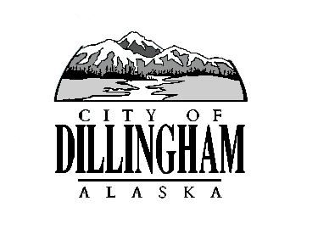

CITY OF

ALASKA

DILLINGHAM

**HMAM**

# DILLINGHAM CITY COUNCIL

David B. Carlson Council Chambers

Dillingham City Hall, 141 Main Street, Dillingham, AK 99576 (907) 842-5212

|  |  |  |
| --- | --- | --- |
| **BOE HEARING** | **1:00 P.M.** | **AUGUST 16, 2018** |

**1. CALL TO ORDER**

**2. ROLL CALL**

**3. APPROVAL OF AGENDA**

**5. LATE FILED APPEALS FOR CONSIDERATION**

1. LFRP18-01, Yonashiro

**6.** **CITIZEN’S DISCUSSION (Prior Notice or Agenda Item)**

**12. MAYOR/COUNCIL COMMENTS**

**13. ADJOURNMENT**