|  |
| --- |
| Alice Ruby, **Mayor** |
| **Council Members** |
| • Chris Napoli (Seat A) • Chris Maines (Seat B) • Aksel Buholm (Seat C) |
| • Curt Armstrong (Seat D) • Andy Anderson (Seat E) • Gregg Marxmiller (Seat F) |

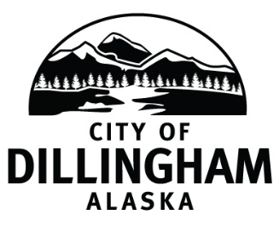

# DILLINGHAM CITY COUNCIL

David B. Carlson Council Chambers

Dillingham City Hall, 141 Main Street, Dillingham, AK 99576 (907) 842-5212

|  |  |  |
| --- | --- | --- |
| **BOE MEETING / HEARING** | **5:30 P.M.** | **MAY 16, 2019** |

**1. CALL TO ORDER**

**2. ROLL CALL**

**3. APPROVAL OF AGENDA** page 1

**4. ASSESSOR’S COMMENTS**

**5. DETERMINE NO. OUTSTANDING APPEALS**

a. Late-Filed Appeals

1. Stephen Elliott page 5

**6. APPEALS FOR CONSIDERATION**

a. Personal Property (all Personal Property Appeals are settled)

1. Settled Appeals page 11

|  |  |  |  |  |
| --- | --- | --- | --- | --- |
| PP19-01 | PP19-02 | PP19-03 | PP19-04 | PP19-05 |

b. Real Property

1. Settled Appeals page 19

|  |  |  |  |  |
| --- | --- | --- | --- | --- |
| RP19-01 | RP19-02 | RP19-03 | RP19-04 | RP19-05 |
| RP19-06 | RP19-07 | RP19-08 | RP19-09 | RP19-10 |
| RP19-11 | RP19-12 | RP19-13 | RP19-14 | RP19-15 |
| RP19-21 | RP19-22 | RP19-23 | RP19-27 | RP19-28 |
| RP19-31 | RP19-32 | RP19-34 | RP19-35 | RP19-36 |
| RP19-37 | RP19-38 | RP19-39 | RP19-41 | RP19-42 |
| RP19-43 |  |  |  |  |

1. Appeals Not Settled
2. RP19-16, Vitus Energy page 51
3. RP19-17, Isaacs page 57
4. RP19-18, Isaacs page 77
5. RP19-19, Isaacs page 87
6. RP19-20, Isaacs page 95
7. RP19-24, Bay Air page 103
8. RP19-25, Schlagel page 121
9. RP19-26, Schlagel page 129
10. RP19-29, Radenbaugh page 147
11. RP19-30, Radenbaugh page 155
12. RP19-33, Ayars page 163
13. RP19-40, Pirilo page 181

**7. CITIZEN DISCUSSION (Prior Notice or Agenda Items)**

**8. COMMITTEE COMMENTS**

**9. ADJOURNMENT**